EXPERIMENT 8 — Subqueries
AIM:
To study and execute simple subqueries, correlated subqueries, and EXISTS queries in MySQL.
PROCEDURE:
- Find vehicles whose price is greater than the average vehicle price.
- Find the vehicle having the maximum price using a subquery.
- Find vehicles whose price is greater than the minimum price.
- Use a correlated subquery to find vehicles priced above the average price of their fuel type.
- Find the most expensive vehicle for each fuel type.
- Use EXISTS to display customers who have purchased a vehicle.
OUT: 1
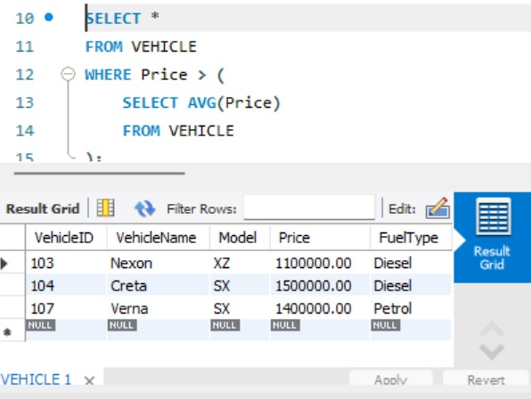
OUT : 2
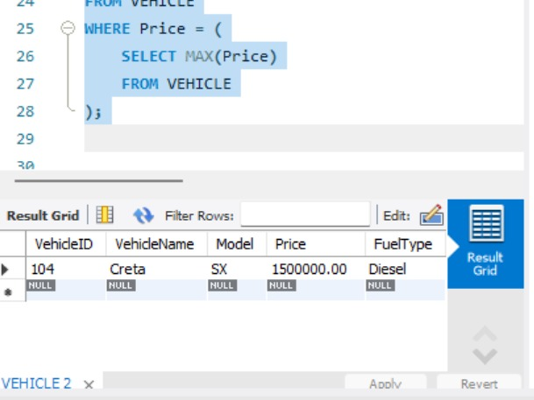
OUT : 3
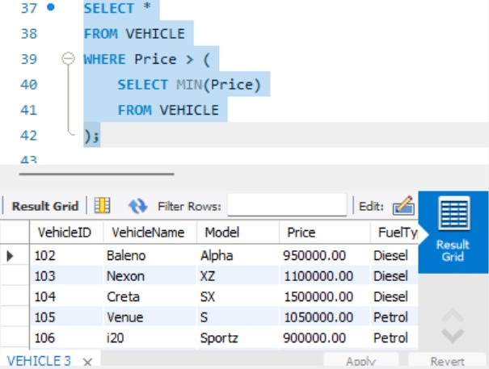
OUT: 4
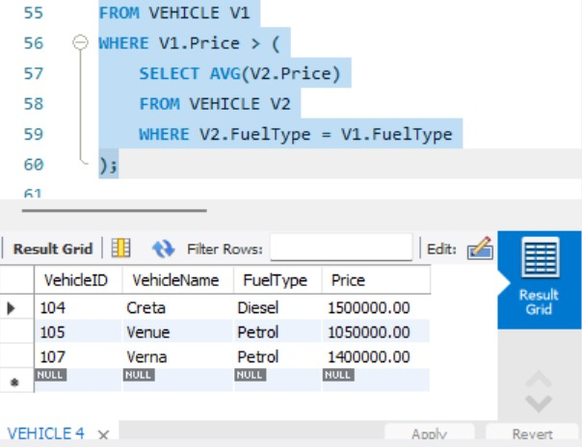
OUT: 5
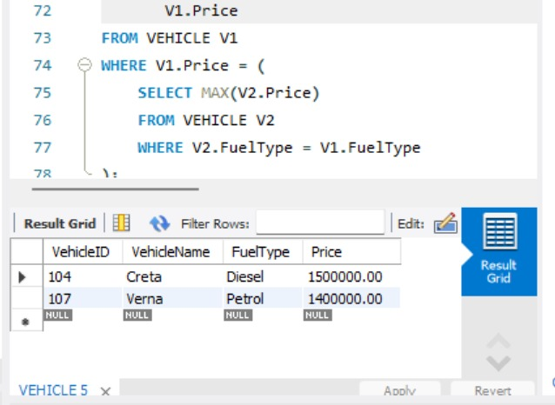
OUT: 6
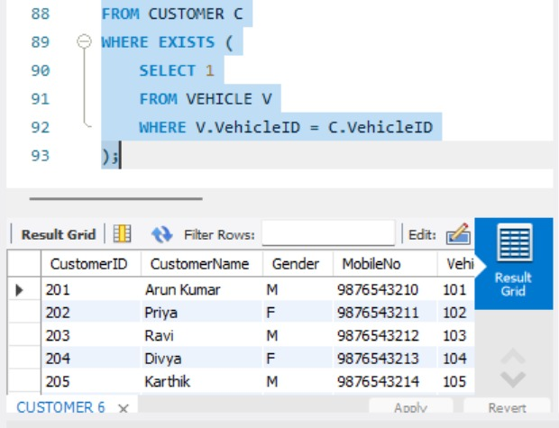
QUERY:
USE AUTOHUB_SHOWROOM;
-- ==========================================
-- 1. SUB QUERY
-- Vehicles whose price is greater than
-- the average price of all vehicles
-- ==========================================
SELECT *
FROM VEHICLE
WHERE Price > (
SELECT AVG(Price)
FROM VEHICLE
);
-- ==========================================
-- 2. SUB QUERY
-- Display vehicles having the maximum price
-- ==========================================
SELECT *
FROM VEHICLE
WHERE Price = (
SELECT MAX(Price)
FROM VEHICLE
);
-- ==========================================
-- 3. SUB QUERY
-- Display vehicles having price greater
-- than the minimum price
-- ==========================================
SELECT *
FROM VEHICLE
WHERE Price > (
SELECT MIN(Price)
FROM VEHICLE
);
-- ==========================================
-- 4. CORRELATED SUB QUERY
-- Display vehicles whose price is greater
-- than the average price of their fuel type
-- ==========================================
SELECT V1.VehicleID,
V1.VehicleName,
V1.FuelType,
V1.Price
FROM VEHICLE V1
WHERE V1.Price > (
SELECT AVG(V2.Price)
FROM VEHICLE V2
WHERE V2.FuelType = V1.FuelType
);
-- ==========================================
-- 5. CORRELATED SUB QUERY
-- Display the most expensive vehicle
-- for each fuel type
-- ==========================================
SELECT V1.VehicleID,
V1.VehicleName,
V1.FuelType,
V1.Price
FROM VEHICLE V1
WHERE V1.Price = (
SELECT MAX(V2.Price)
FROM VEHICLE V2
WHERE V2.FuelType = V1.FuelType
);
-- ==========================================
-- 6. CORRELATED QUERY USING EXISTS
-- Display customers who have purchased
-- a vehicle
-- ==========================================
SELECT *
FROM CUSTOMER C
WHERE EXISTS (
SELECT 1
FROM VEHICLE V
WHERE V.VehicleID = C.VehicleID
);
RESULT:
Thus, simple subqueries, correlated subqueries, and EXISTS queries were successfully executed to retrieve the required data.

